[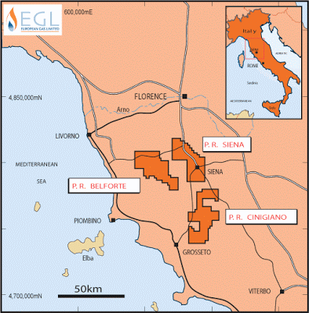](http://2.bp.blogspot.com/-eO7riB-OWtk/T9F4kLKNbhI/AAAAAAAAEg8/0lBG0pFI69I/s1600/tuscany_map.gif)

Cartina 1

[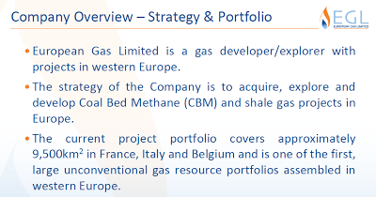](http://2.bp.blogspot.com/-hR4XS0P2A8s/T9F2FharD9I/AAAAAAAAEg0/7nOqXrZ1AHk/s1600/Screenshot.png)

Cartina 2

[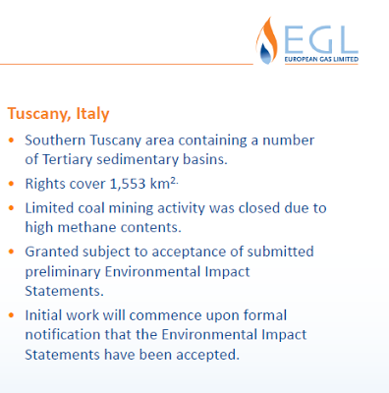](http://1.bp.blogspot.com/-2LTJ1mUjfDM/T9Fxgu1yCEI/AAAAAAAAEgI/cePKtAIQGBY/s1600/Screenshot-1.png)

Cartina 3

[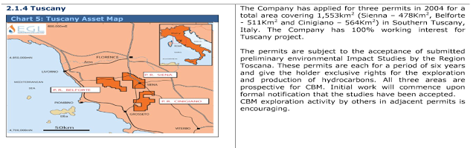](http://4.bp.blogspot.com/-4b7CcUopOa4/T9F5MWC5gEI/AAAAAAAAEhE/X2lZawgGQek/s1600/Screenshot-2.png)

Cartina 4